Exp 1:
Implement and demonstrate the FIND-S algorithm for finding the most specific hypothesis based on a given set of training data samples.
Code:
import pandas as pd
# Step 1: Load dataset
data = pd.read_csv("/content/PlayTennis.csv")
print("Dataset Preview:\n")
print(data.head())
# Step 2: Separate features and target
X = data.iloc[:, :-1].values # outlook, temp, humidity, windy
y = data.iloc[:, -1].values # play (yes / no)
# Step 3: Initialize hypothesis with FIRST POSITIVE example
hypothesis = None
for i in range(len(y)):
if y[i].lower() == "yes":
hypothesis = X[i].copy()
break

print("\nInitial Hypothesis (First Positive Example):")
print(hypothesis)

# Step 4: Apply FIND-S algorithm
for i in range(len(X)):
if y[i].lower() == "yes": # ONLY positive examples
for j in range(len(hypothesis)):
if X[i][j] != hypothesis[j]:
hypothesis[j] = "?"
print(f"After training example {i+1}: {hypothesis}")

# Step 5: Final hypothesis
print("\nFinal Most Specific Hypothesis:")
print(hypothesis)
output:
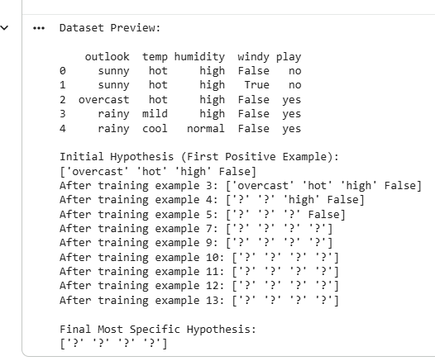
Exp 2 :
For a given set of training data examples stored in a .CSV file, implement and demonstrate the Candidate-Elimination algorithm in python to output a description of the set of all hypotheses consistent with the training examples
Code :
import pandas as pd
# Step 1: Load CSV dataset
data = pd.read_csv("/content/PlayTennis.csv")
print("Dataset Preview:\n")
print(data)
# Step 2: Use ALL examples
X = data.iloc[:, :-1].values # outlook, temp, humidity, windy
y = data.iloc[:, -1].values # play (yes / no)
num_attr = X.shape[1]
# Step 3: Extract attribute domains
domains = []
for i in range(num_attr):
domains.append(list(set(X[:, i])))
# Step 4: Initialize S and G
S = None
G = [['?'] * num_attr]
# Helper functions
def covers(h, x):
"""Check if hypothesis h covers instance x"""
return all(h[i] == '?' or h[i] == x[i] for i in range(len(h)))
def more_general_or_equal(h1, h2):
"""Check if h1 is more general than or equal to h2"""
return all(h1[i] == '?' or h1[i] == h2[i] for i in range(len(h1)))
# Step 5: Candidate-Elimination on ALL examples
for i in range(len(X)):
instance = X[i]
label = y[i].lower()
# ---------- POSITIVE EXAMPLE ----------
if label == 'yes':
if S is None:
S = list(instance)
else:
for j in range(num_attr):
if S[j] != instance[j]:
S[j] = '?'
# Remove inconsistent hypotheses from G
G = [g for g in G if covers(g, instance)]

# ---------- NEGATIVE EXAMPLE ----------
else:
if S is None:
continue

new_G = []
for g in G:
if covers(g, instance):
for j in range(num_attr):
if g[j] == '?':
for value in domains[j]:
if value != instance[j]:
new_h = g.copy()
new_h[j] = value
if more_general_or_equal(new_h, S):
new_G.append(new_h)
else:
new_G.append(g)
G = new_G
print(f"\nAfter example {i+1} ({label}):")
print("S =", S)
print("G =", G)
# Step 6: Final Version Space
print("Final Version Space (All Examples)")
print("Specific Boundary (S):", S)
print("General Boundary (G):", G)
output:
Dataset Preview:
outlook temp humidity windy play
0 sunny hot high False no
1 sunny hot high True no
2 overcast hot high False yes
3 rainy mild high False yes
4 rainy cool normal False yes
5 rainy cool normal True no
6 overcast cool normal True yes
7 sunny mild high False no
8 sunny cool normal False yes
9 rainy mild normal False yes
10 sunny mild normal True yes
11 overcast mild high True yes
12 overcast hot normal False yes
13 rainy mild high True no

After example 3 (yes):
S = ['overcast', 'hot', 'high', False]
G = [['?', '?', '?', '?']]
After example 4 (yes):
S = ['?', '?', 'high', False]
G = [['?', '?', '?', '?']]
After example 5 (yes):
S = ['?', '?', '?', False]
G = [['?', '?', '?', '?']]
After example 6 (no):
S = ['?', '?', '?', False]
G = [['?', '?', '?', False]]
After example 7 (yes):
S = ['?', '?', '?', '?']
G = []
After example 8 (no):
S = ['?', '?', '?', '?']
G = []
After example 9 (yes):
S = ['?', '?', '?', '?']
G = []
After example 10 (yes):
S = ['?', '?', '?', '?']
G = []
After example 11 (yes):
S = ['?', '?', '?', '?']
G = []
After example 12 (yes):
S = ['?', '?', '?', '?']
G = []
After example 13 (yes):
S = ['?', '?', '?', '?']
G = []
After example 14 (no):
S = ['?', '?', '?', '?']
G = []
Final Version Space (All Examples)
Specific Boundary (S): ['?', '?', '?', '?']
General Boundary (G): []
Exp 3:
Demonstrate the working of the decision tree based ID3 algorithm. Use an appropriate data set for building the decision tree and apply this knowledge to classify a new sample.
Code :
# Step 1: Import Libraries
import pandas as pd
from sklearn.preprocessing import LabelEncoder
from sklearn.tree import DecisionTreeClassifier, plot_tree
import matplotlib.pyplot as plt
# Step 2: Load Dataset
data = pd.read_csv("/content/play_tennis.csv")
# Drop the 'day' column (just ID)
data = data.drop('day', axis=1)
# Step 3: Encode categorical features
le_dict = {}
for col in data.columns:
le = LabelEncoder()
data[col] = le.fit_transform(data[col])
le_dict[col] = le
# Separate features and target
X = data.iloc[:, :-1]
y = data.iloc[:, -1]
# Step 4: Train Decision Tree using ID3 (entropy)
clf = DecisionTreeClassifier(criterion='entropy')
clf.fit(X, y)
# Step 5: Display the tree (graphically)
plt.figure(figsize=(20,10))
plot_tree(clf,
feature_names=X.columns,
class_names=le_dict['play'].classes_,
filled=True,
rounded=True,
fontsize=12)
plt.title("Decision Tree (ID3) - Play Tennis Dataset")
plt.show()
# Step 6: Classify a new sample
new_sample = pd.DataFrame([["Sunny", "Cool", "High", "Weak"]],
columns=['outlook','temp','humidity','wind'])
# Encode new sample
for col in new_sample.columns:
le = le_dict[col]
new_sample[col] = le.transform(new_sample[col])
# Predict
prediction = clf.predict(new_sample)
predicted_class = le_dict['play'].inverse_transform(prediction)
print("\nNew Sample Prediction:")
print(new_sample)
print("Predicted Class:", predicted_class[0])
Output :
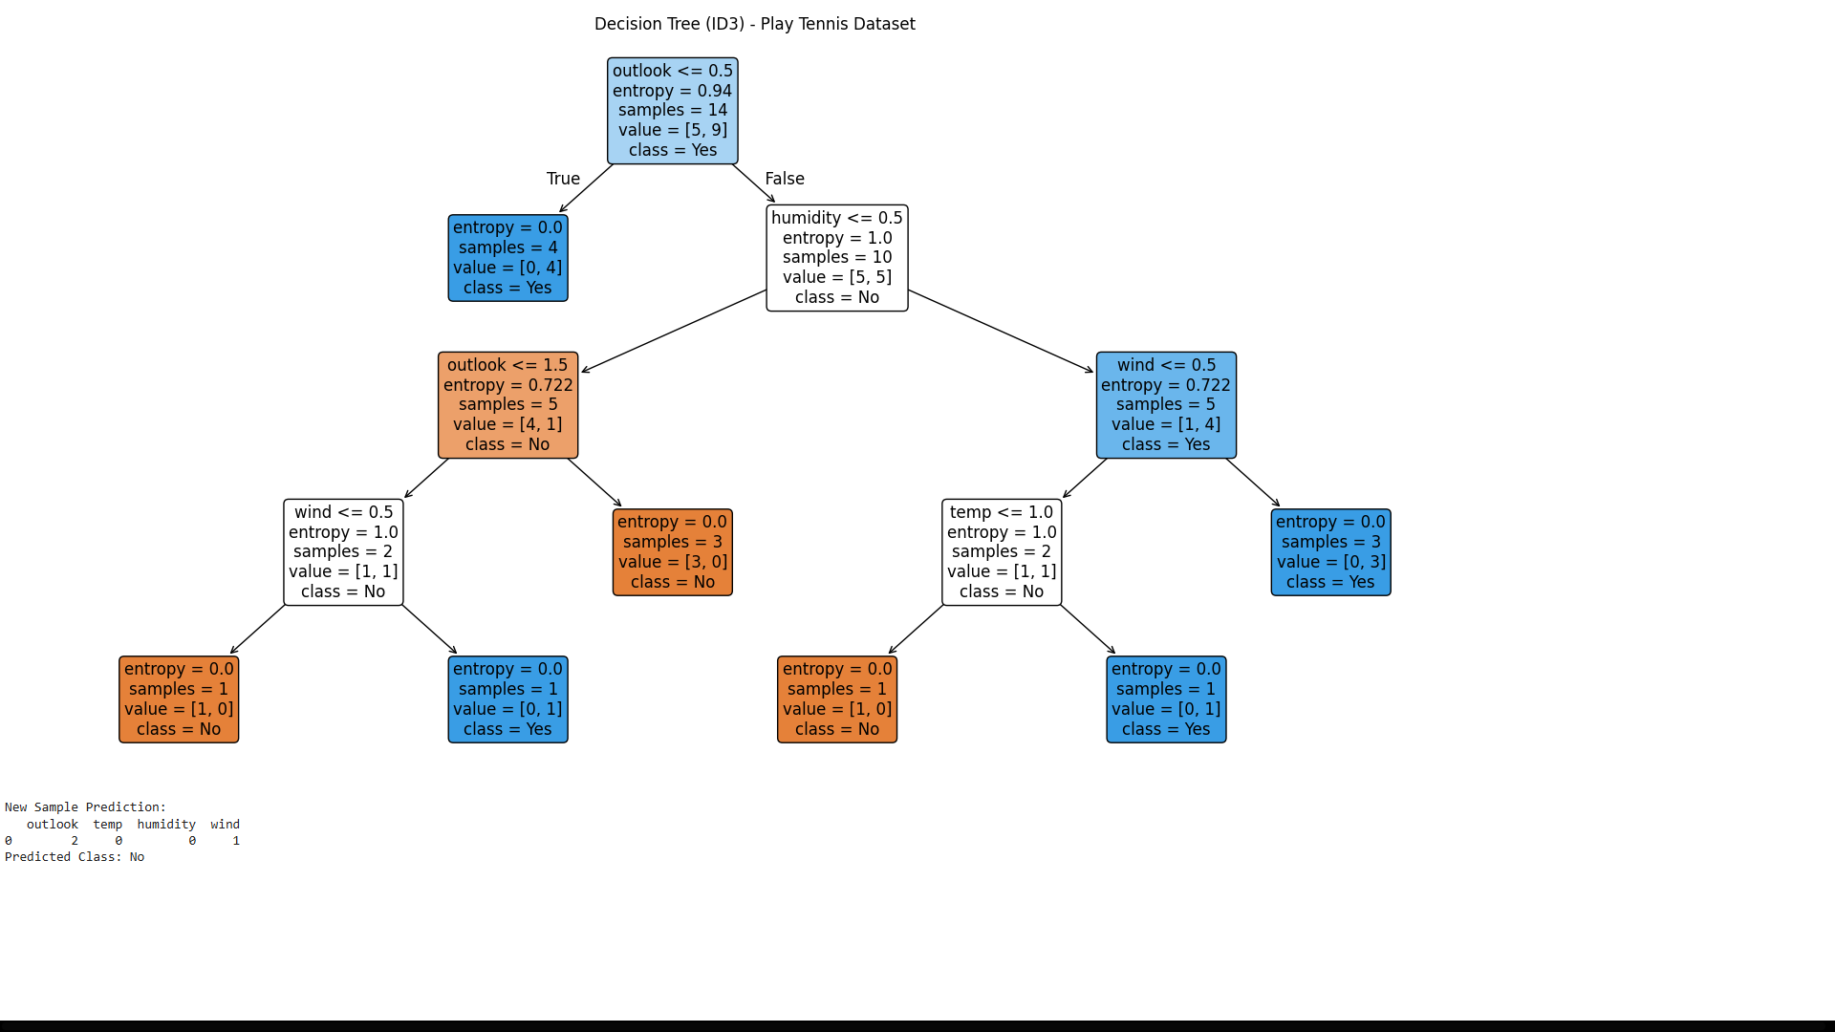
Exp 4:
Build an Artificial Neural Network by implementing the Backpropagation algorithm and test the same using appropriate data sets.
Code:
import numpy as np
import pandas as pd
from sklearn.model_selection import train_test_split
from sklearn.preprocessing import StandardScaler
# Load dataset
data = pd.read_csv("/content/diabetes.csv")
# Separate features and target
X = data.iloc[:, :-1].values
y = data.iloc[:, -1].values
# Normalize features
scaler = StandardScaler()
X = scaler.fit_transform(X)
# Train-test split
X_train, X_test, y_train, y_test = train_test_split(X, y, test_size=0.2, random_state=42)
# Convert target to one-hot encoding (binary classification)
y_train = y_train.reshape(-1, 1)
y_test = y_test.reshape(-1, 1)
# ANN Implementation (Backpropagation)
class NeuralNetwork:
def __init__(self, input_size, hidden_size, output_size, learning_rate=0.01, epochs=5000):
self.input_size = input_size
self.hidden_size = hidden_size
self.output_size = output_size
self.learning_rate = learning_rate
self.epochs = epochs

# Initialize weights
self.W1 = np.random.randn(self.input_size, self.hidden_size)
self.b1 = np.zeros((1, self.hidden_size))
self.W2 = np.random.randn(self.hidden_size, self.output_size)
self.b2 = np.zeros((1, self.output_size))

def sigmoid(self, z):
return 1 / (1 + np.exp(-z))

def sigmoid_derivative(self, z):
return z * (1 – z)
def train(self, X, y):
for epoch in range(self.epochs):
# Forward pass
z1 = np.dot(X, self.W1) + self.b1
a1 = self.sigmoid(z1)
z2 = np.dot(a1, self.W2) + self.b2
a2 = self.sigmoid(z2)
# Compute error
error = y - a2
# Backpropagation
d_a2 = error * self.sigmoid_derivative(a2)
d_W2 = np.dot(a1.T, d_a2)
d_b2 = np.sum(d_a2, axis=0, keepdims=True)
d_a1 = np.dot(d_a2, self.W2.T) * self.sigmoid_derivative(a1)
d_W1 = np.dot(X.T, d_a1)
d_b1 = np.sum(d_a1, axis=0, keepdims=True)

# Update weights
self.W1 += self.learning_rate * d_W1
self.b1 += self.learning_rate * d_b1
self.W2 += self.learning_rate * d_W2
self.b2 += self.learning_rate * d_b2
# Print loss occasionally
if epoch % 1000 == 0:
loss = np.mean(np.square(error))
print(f"Epoch {epoch}, Loss: {loss:.4f}")
def predict(self, X):
z1 = np.dot(X, self.W1) + self.b1
a1 = self.sigmoid(z1)
z2 = np.dot(a1, self.W2) + self.b2
a2 = self.sigmoid(z2)
return (a2 > 0.5).astype(int)
# Train and Test ANN
# Define network: input = 8 features, hidden = 10 neurons, output = 1 (binary classification)
nn = NeuralNetwork(input_size=X_train.shape[1], hidden_size=10, output_size=1, learning_rate=0.01, epochs=5000)
# Train
nn.train(X_train, y_train)
# Test
y_pred = nn.predict(X_test)
print(f"\nTest Accuracy: {accuracy * 100:.2f}%")
Output :
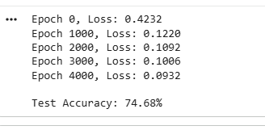
Exp 5:
Write a program for Implementation of K-Nearest Neighbours (K-NN) in Python
Code :
import pandas as pd
from sklearn.model_selection import train_test_split
from sklearn.preprocessing import StandardScaler
from sklearn.neighbors import KNeighborsClassifier
from sklearn.metrics import accuracy_score, classification_report
# Load dataset (example: diabetes.csv)
# Replace with your dataset path
data = pd.read_csv("/content/diabetes.csv")
# Separate features and target
X = data.iloc[:, :-1].values
y = data.iloc[:, -1].values
# Preprocessing
scaler = StandardScaler()
X = scaler.fit_transform(X)
# Train-test split
X_train, X_test, y_train, y_test = train_test_split(
X, y, test_size=0.2, random_state=42
)
# KNN Classifier
k = 5 # number of neighbors
knn = KNeighborsClassifier(n_neighbors=k)
# Train
knn.fit(X_train, y_train)
# Predict
y_pred = knn.predict(X_test)
# Evaluation
print(f"Accuracy: {accuracy_score(y_test, y_pred) * 100:.2f}%")
print("\nClassification Report:\n", classification_report(y_test, y_pred))
Output :
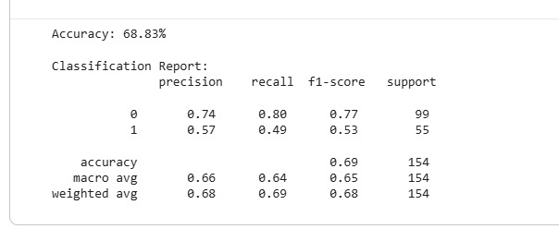
Exp 6:
Write a program to implement Naïve Bayes algorithm in python and to display the results using confusion matrix and accuracy.
Code:
import pandas as pd
from sklearn.model_selection import train_test_split
from sklearn.preprocessing import StandardScaler
from sklearn.naive_bayes import GaussianNB
from sklearn.metrics import confusion_matrix, classification_report, accuracy_score
# --- Load Dataset ---
df = pd.read_csv('/content/diabetes.csv')
# Features and labels
X = df.iloc[:, :-1].values # all columns except last
y = df.iloc[:, -1].values # last column (Outcome: 0 or 1)
# --- Standardize features (important for continuous variables) ---
scaler = StandardScaler()
X = scaler.fit_transform(X)
# --- Train-test split ---
X_train, X_test, y_train, y_test = train_test_split(X, y, test_size=0.2, random_state=42)
# --- Initialize and train Gaussian Naive Bayes ---
model = GaussianNB()
model.fit(X_train, y_train)
# --- Make predictions ---
y_pred = model.predict(X_test)
# --- Accuracy ---
accuracy = accuracy_score(y_test, y_pred)
print(f"Accuracy: {accuracy*100:.2f}%")
# --- Confusion Matrix ---
cm = confusion_matrix(y_test, y_pred)
print("\nConfusion Matrix:")
print(cm)
Output:
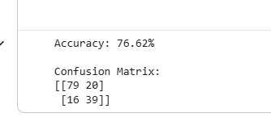
Exp 7 :
Write a program to implement Logistic Regression (LR) algorithm in python
Code:
import pandas as pd
from sklearn.model_selection import train_test_split
from sklearn.preprocessing import StandardScaler
from sklearn.linear_model import LogisticRegression
from sklearn.metrics import confusion_matrix, classification_report, accuracy_score

# --- Load Dataset ---
df = pd.read_csv('/content/diabetes.csv')
# Features and labels
X = df.iloc[:, :-1].values # all columns except last
y = df.iloc[:, -1].values # last column (Outcome: 0 or 1)
# --- Standardize features ---
scaler = StandardScaler()
X = scaler.fit_transform(X)
# --- Train-test split ---
X_train, X_test, y_train, y_test = train_test_split(X, y, test_size=0.2, random_state=42)
# --- Logistic Regression Model ---
model = LogisticRegression()
model.fit(X_train, y_train)
# --- Predictions ---
y_pred = model.predict(X_test)
# --- Accuracy ---
accuracy = accuracy_score(y_test, y_pred)
print(f"Accuracy: {accuracy*100:.2f}%")
# --- Confusion Matrix ---
cm = confusion_matrix(y_test, y_pred)
print("\nConfusion Matrix:")
print(cm)
# --- Classification Report ---
cr = classification_report(y_test, y_pred)
print("\nClassification Report:")
print(cr)
Output:
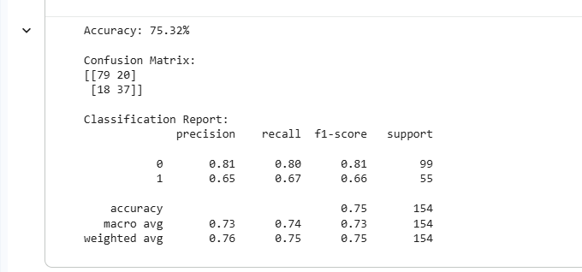
Exp 8 :
Write a program to implement Linear Regression (LR) algorithm in python
Code :
import pandas as pd
import matplotlib.pyplot as plt
from sklearn.model_selection import train_test_split
from sklearn.linear_model import LinearRegression
from sklearn.preprocessing import OneHotEncoder
from sklearn.compose import ColumnTransformer
from sklearn.metrics import mean_squared_error, r2_score
# Load dataset
data = pd.read_csv("/content/insurance.csv")
# Separate features and target
X = data.drop("charges", axis=1)
y = data["charges"]
# Preprocessing (handle categorical variables)
categorical_features = ["sex", "smoker", "region"]
# One-hot encode categorical features
ct = ColumnTransformer(
transformers=[("encoder", OneHotEncoder(drop="first"), categorical_features)],
remainder="passthrough"
)
X = ct.fit_transform(X)
# Train-test split
X_train, X_test, y_train, y_test = train_test_split(
X, y, test_size=0.2, random_state=42
)
# Linear Regression Model
lr = LinearRegression()
lr.fit(X_train, y_train)

# Predict
y_pred = lr.predict(X_test)
# Evaluation
print("Mean Squared Error:", mean_squared_error(y_test, y_pred))
print("R2 Score:", r2_score(y_test, y_pred))
# Visualization: Actual vs Predicted
plt.scatter(y_test, y_pred, color="blue", alpha=0.6, label="Predicted vs Actual")
plt.plot([y_test.min(), y_test.max()],
[y_test.min(), y_test.max()],
color="red", linewidth=2, label="Perfect Prediction")
plt.xlabel("Actual Charges")
plt.ylabel("Predicted Charges")
plt.title("Linear Regression: Actual vs Predicted Charges")
plt.legend()
plt.show()
Output :
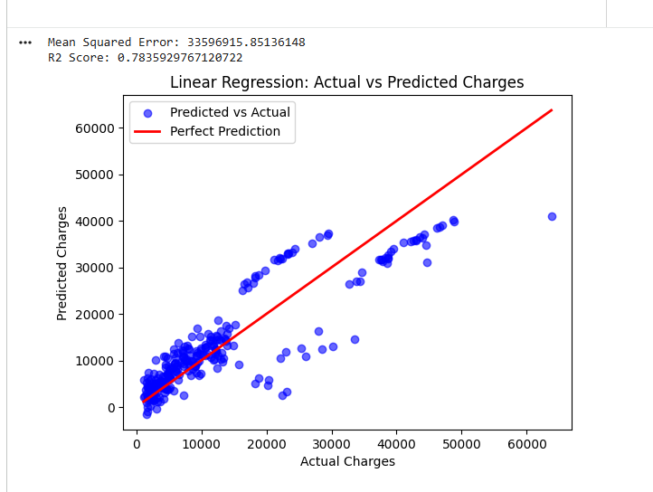
Exp 9 :
Compare Linear and Polynomial Regression using Python
Code :
import pandas as pd
import matplotlib.pyplot as plt
from sklearn.model_selection import train_test_split
from sklearn.linear_model import LinearRegression
from sklearn.preprocessing import PolynomialFeatures, OneHotEncoder
from sklearn.compose import ColumnTransformer
from sklearn.metrics import mean_squared_error, r2_score
# Load dataset
data = pd.read_csv("/content/insurance.csv")
print(data.head())
# Separate features and target
X = data.drop("charges", axis=1)
y = data["charges"]
# Handle categorical variables
categorical_features = ["sex", "smoker", "region"]
ct = ColumnTransformer(
transformers=[("encoder", OneHotEncoder(drop="first"), categorical_features)],
remainder="passthrough"
)
X = ct.fit_transform(X)
# Train-test split
X_train, X_test, y_train, y_test = train_test_split(
X, y, test_size=0.2, random_state=42
)
# Linear Regression
lin_reg = LinearRegression()
lin_reg.fit(X_train, y_train)
y_pred_lin = lin_reg.predict(X_test)
print("Linear Regression MSE:", mean_squared_error(y_test, y_pred_lin))
print("Linear Regression R2:", r2_score(y_test, y_pred_lin))
# Polynomial Regression (degree=2)
poly = PolynomialFeatures(degree=2)
X_train_poly = poly.fit_transform(X_train)
X_test_poly = poly.transform(X_test)
poly_reg = LinearRegression()
poly_reg.fit(X_train_poly, y_train)
y_pred_poly = poly_reg.predict(X_test_poly)
print("Polynomial Regression MSE:", mean_squared_error(y_test, y_pred_poly))
print("Polynomial Regression R2:", r2_score(y_test, y_pred_poly))
# Visualization: Actual vs Predicted
plt.figure(figsize=(10,5))
plt.scatter(y_test, y_pred_lin, color="blue", alpha=0.6, label="Linear Regression")
plt.scatter(y_test, y_pred_poly, color="green", alpha=0.6, label="Polynomial Regression (deg=2)")
plt.plot([y_test.min(), y_test.max()],
[y_test.min(), y_test.max()],
color="red", linewidth=2, label="Perfect Prediction")
plt.xlabel("Actual Charges")
plt.ylabel("Predicted Charges")
plt.title("Linear vs Polynomial Regression on Insurance Dataset")
plt.legend()
plt.show()
output :
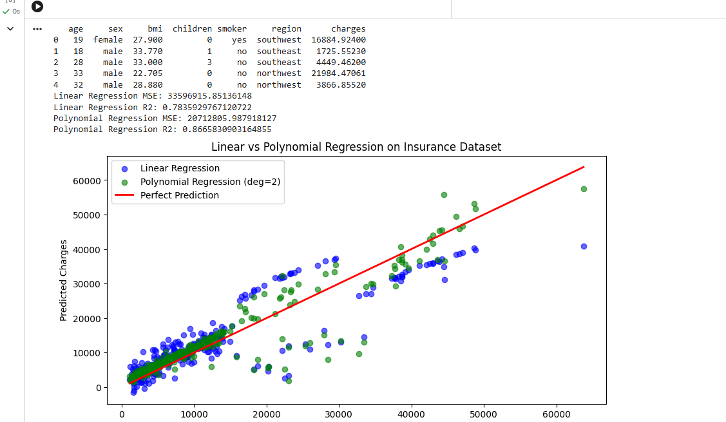
Exp 10:
Write a Python Program to Implement Expectation & Maximization Algorithm
Code :
import pandas as pd
import numpy as np
import matplotlib.pyplot as plt
from sklearn.mixture import GaussianMixture

# Step 1: Load Kaggle Insurance dataset

data = pd.read_csv("/content/insurance.csv")
X = data[["bmi", "charges"]].values

# Step 2: Apply EM via Gaussian Mixture Model
gmm = GaussianMixture(n_components=2, random_state=42)
gmm.fit(X)
labels = gmm.predict(X)

# Step 3: Print learned parameters
print("Means:", gmm.means_)
print("Covariances:", gmm.covariances_)
print("Weights:", gmm.weights_)

# Step 4: Visualization
plt.figure(figsize=(10,6))
plt.scatter(X[:,0], X[:,1], c=labels, cmap="viridis", s=40, alpha=0.7)
plt.xlabel("BMI")
plt.ylabel("Charges")
plt.title("EM Clustering on Insurance Dataset (BMI vs Charges)")
plt.colorbar(label="Cluster")
plt.show()
Output:
